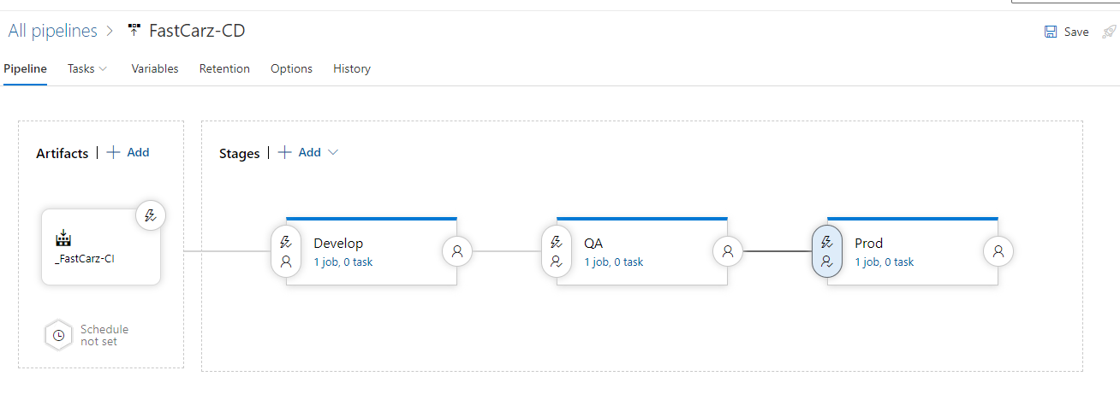

**4**

**8**

**7**

**6**

**5**

**3**

**2**

**1**

1. CI pipeline output added as Artifact to CD pipeline
2. Automatic trigger is set to allow to initiate CD pipeline once the CI pipeline is successfully run
3. First stage of the CD is to deploy on “Develop” environment
4. Automatic trigger with no pre-deployment approval is set for develop environment
5. Second stage of deployment is QA stage
6. The deployment will trigger after develop stage is completed and we have enabled pre-deployment approver for QA stage
7. Third stage of the deployment is Production
8. The deployment to Prod stage will trigger after QA stage is completed successfully and we have enabled pre-deployment approver for Prod stage which will notify approvers to approve before starting the deployment tasks.